**The key contribution to the project:**

My role is the ‘Integrator’, and my key contribution is integrating all components as a product. In general, I did two jobs: First, I implemented the main controller for the Recyclotron, and then integrated it with all other components. Second, I improved the integration of the sub teams (hardware team and software team) by frequently communicating and helping between them.

For the integration, I have been negotiating between groups every time a new development starts. This is to establish unified working standards across the whole team. From practice, the unified standards dramatically boosted the efficiency of the integration. Most of the components work together with little or none adjustment, therefore, more time was gained for teammates to research and implement. The standards include (Graph 1,2):

* The APIs of the ML Vision model
* The APIs of the payload motion controller
* The APIs of the main controller (All arrows going out from ‘Recyclotron Computer’)
* The APIs of the sensors and user interfaces
* The dimensions of the payload & devices mounting locations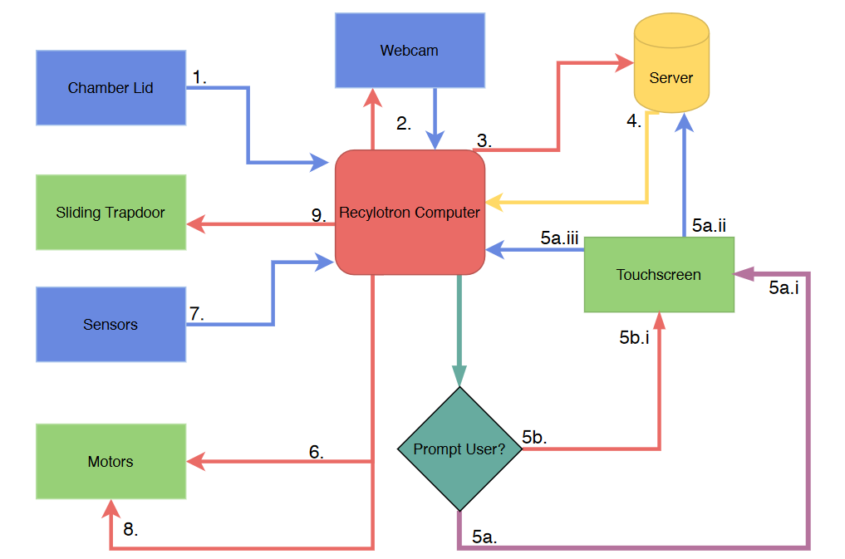

Graph 1: the integration of the software system.   
API calls are colour coded. The number is the order of API calls

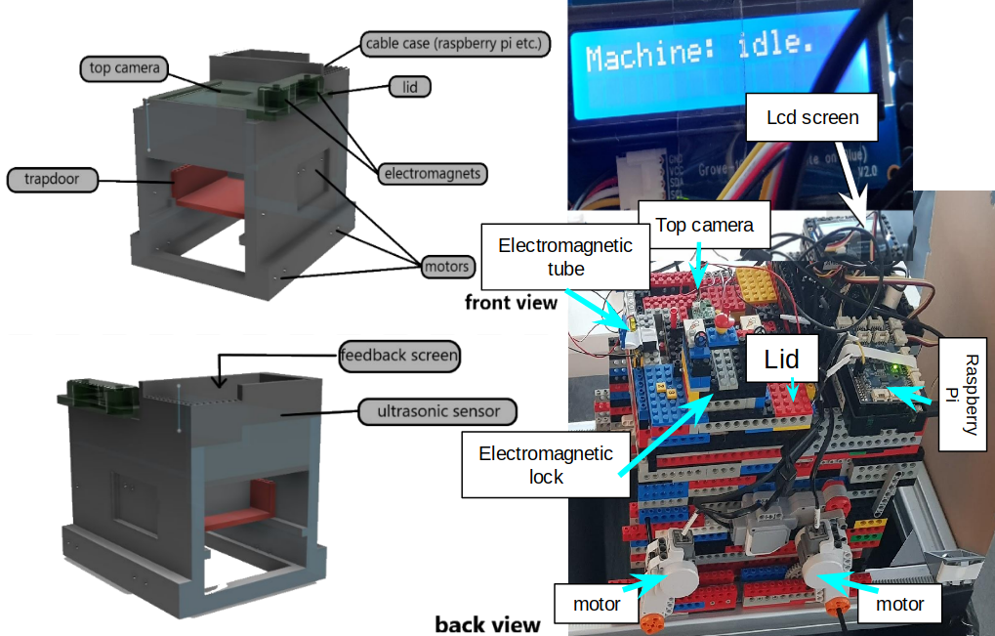Graph 2: the integration of the hardware

I self-developed the main controller of the Recyclotron. The controller is in ‘idle’ state by default. When a user opens the lid of the Recyclotron, a ‘lid up’ signal is triggered. The controller changes to ‘lid up’ state and waits for the 'lid down' signal. Once the user has closed the lid after he put the trash into the Recyclotion, the ‘lid down’ signal is triggered. Then the controller changes to 'lid down' state while locking the lid. After that, the controller changes to the 'processing' state. At this stage, a photo of the trash is taken and sent to the remote server. The server classifies its category then returns the result to the controller. Finally, according to the result from the server, the controller moves the Recyclotron to the target bin and disposes of the trash. After all, the controller returns to the 'idle' state.

For team communication, people from the sub groups had no idea about what the other team was doing. Because, after the group meeting, there is a lack of communication between them due to their less synchronised working times. So, in turn, I participated with either group for helping and clarifying the uncertainties of the project (for them and also myself). This potentially improves the efficiency of the whole group while preventing misunderstandings.

**What I learnt about myself**

From the course, I think I was a competent integrator. I came up with efficient strategies which avoid potential problems and achieve the goal. However, the lack of neural network knowledge forces me to spend time learning it. I learnt the convolutional neural network (CNN) and transfer learning. We adapted a pre-trained general object classifier, ResNet-50, to classify trash. We make use of the ResNet-50 to extract ground features of images, then fine-tune it to classify on trash items. Ultimately, we achieved 80% mean Average Precision with 4 trash categories, which is very impressive.

I learnt a lot about the hardware. For instance, I programmed single-board computers to control motors. Again, I gained experience with prototyping and modelling with lego. However, we made serious mistakes with 3D modelling. The 3D model was too complicated to 3D-print, which took 5 days. Even worse, the model was designed with too little tolerance, so components could hardly fit in. Consequently, we went back to the lego model. In hindsight, we should model modularised with minimised cavities. In that way, the 3D-printing could be much faster and allow more flexibility to modify it later.

**What I learnt about the group work**

Communication is the most important thing. People should always ask when they are not sure about something or get stuck to some problems. Co-operation makes work more enjoyable and efficient. Make less ambitious goals and keep making progress has the highest priority. Besides, allowing different opinions is always beneficial. Preparation before meetings also improves efficiency a lot. Stick with the plan and achieve it. Frequently changing the plan is a waste of time. Try to be optimistic.

**What I learnt about the project management**

We did sufficient research about the project, which helped people to understand the difficulties of it. According to the advantages of our team, we are competent to complete the project. We identified stakeholders, clients and the market. Then the group planned the objectives that meet the demands. Lastly, we listed out potential risks and came up with corresponding countermeasures. Setting up critical milestones is essential to ensure the progress of the project.

It is very important to keep logs/documents, especially the solution to some tricky problems. When something goes wrong, people can reproduce the work as before. This, indeed, saved us from accidentally breaking a Raspberry Pi, the configurations and packages were restored very quickly with the document.